CitiSense: A Mobile-Based Barangay Complaint and Recommendation System

A Software Engineering 1 Project presented to the faculty of
Department of Computing and Informatics
of the City College of Calamba
Calamba City, Laguna

BACHELOR OF SCIENCE IN COMPUTER SCIENCE

COPRE, RALPH LAURENCE D.
CREDO, ALYSSA JOY M.
LOPEZ, TIMOTHY JOHN
II- CS1
September 2026

Chapter 1

THE PROBLEM AND ITS BACKGROUND
Barangays are the smallest unit of government in the Philippines and are responsible for addressing community concerns and delivering basic public services. However, many barangays still rely on traditional methods such as suggestion boxes, paper-based forms, and face-to-face reporting in collecting feedback from residents. These manual processes are often slow, unorganized, and prone to delays, resulting in inefficiencies in addressing community issues [1]. With the advancement of information and communication technology, digital platforms have been widely adopted in various sectors to improve efficiency, transparency, and accessibility. In the context of governance, e-governance systems enable faster data collection, better organization of information, and improved communication between citizens and government units [2]. These systems allow real-time interaction and provide a structured way of managing public concerns, which significantly enhances service delivery.
Despite these advancements, many barangays in the Philippines have yet to fully adopt digital solutions for feedback management. Existing systems often focus only on record-keeping or complaint logging without providing intelligent analysis or decision support features [3], [4]. As a result, barangay officials may find it difficult to prioritize issues and respond effectively to community needs. To address this gap, the proposed system, CitiSense: A Mobile-Based Barangay Complaint and Recommendation System, aims to provide a more efficient and intelligent approach to feedback management. The system allows residents to submit feedback through a mobile application while utilizing sentiment analysis to automatically classify responses as positive, negative, or neutral. Sentiment analysis, as defined by Tan et al. [5], is a computational technique used to analyze opinions and emotions expressed in textual data, and recent studies confirm its effectiveness in governance and citizen engagement. This capability enables barangay officials to quickly understand the nature of concerns and identify urgent issues.
Furthermore, the system incorporates a recommendation feature that suggests possible actions based on analyzed feedback. Recommendation systems are widely used to support decision-making by identifying patterns and providing relevant suggestions based on available data. Kumar and Singh [6] emphasized that sentiment-aware recommendation systems can be adapted beyond e-commerce to public service prioritization, while Zhang et al. [3] demonstrated that integrating sentiment analysis with rule-based recommendations improves responsiveness in structured environments. By integrating these technologies, the proposed system aims to improve responsiveness, transparency, and efficiency in barangay governance.
Project Context
Barangays, as the smallest unit of government in the Philippines, are tasked with addressing community concerns and delivering essential public services. However, many barangays still rely on traditional feedback mechanisms such as paper forms, suggestion boxes, and face-to-face reporting. These manual processes are slow, unorganized, and often result in delayed responses, leaving residents dissatisfied and officials struggling to prioritize issues. The current situation reflects a gap between citizen expectations for efficient service delivery and the limited capacity of barangay officials to process and act on community concerns effectively.
The problem lies in the absence of intelligent digital platforms that go beyond simple record-keeping. Existing systems often focus only on storing complaints without providing analytical tools to classify feedback or guide officials in decision-making. This lack of intelligent support makes it difficult for barangay staff to identify urgent issues, allocate resources efficiently, and maintain transparency in governance. As a result, community concerns are either delayed or inadequately addressed, weakening citizen trust and participation in local governance.
To address this, the proposed system, CitiSense: A Mobile-Based Barangay Complaint and Recommendation System, introduces a modern solution that integrates Natural Language Processing (NLP), Naïve Bayes classification, and a rule-based recommendation feature. NLP is used to process and understand the textual feedback submitted by residents, converting raw sentences into structured data by tokenizing words, removing stop words, and extracting features. This ensures that the system can capture meaning from everyday language. Once processed, the feedback is classified using the Naïve Bayes algorithm with TF-IDF, which calculates the probability that a given text expresses positive, negative, or neutral sentiment. This lightweight and efficient approach is well-suited for short community feedback. After classification, the rule-based recommendation system applies predefined logic to prioritize issues and suggest actions for barangay officials. For example, negative feedback mentioning “water supply” can be flagged as urgent, while repeated reports of the same issue can trigger immediate recommendations for intervention.
This integration ensures that feedback is not only collected but also transformed into actionable insights. By digitizing feedback collection and embedding NLP-driven sentiment analysis with rule-based recommendations, CitiSense empowers residents to voice concerns conveniently while equipping officials with tools to make evidence-based decisions. The rationale for developing this system lies in its potential to improve responsiveness, transparency, and efficiency in barangay governance. Its relevance is underscored by the increasing demand for e-governance solutions in the Philippines, where digital transformation is seen as a pathway to more accountable and participatory governance.
In essence, the need for this software solution arises from the limitations of traditional feedback systems and the growing expectation for intelligent digital governance. CitiSense provides a structured, NLP-powered, and accessible platform that ensures community voices are heard, analyzed, and acted upon, making it a vital innovation for barangay-level governance in the modern era.

Research Objectives
General Aim
This study aims to develop CitiSense, a mobile-based complaint and recommendation system designed to streamline community feedback, apply intelligent analysis, and provide actionable recommendations to improve responsiveness and decision-making in barangay governance.
Specific Objectives
This study aims to design and develop a mobile application that enables barangay residents to easily submit feedback, complaints, and suggestions as follows:
- To design and develop a mobile application that allows barangay residents to submit feedback, complaints, and suggestions easily.
- To implement a sentiment analysis algorithm such as Naive Bayes that automatically classifies feedback into positive, negative, or neutral.
- To test and validate the accuracy and performance of the implemented algorithms in analyzing feedback and generating appropriate results.
- To evaluate the effectiveness of the proposed system based on ISO/IEC 25010:2023 software product quality model standards, specifically in terms of:
4.1 Functional Suitability
4.2 Performance Efficiency
4.3 Compatibility
4.4 Usability
4.5 Reliability
4.6 Security
4.7 Maintainability
4.8 Portability

Research Framework
Theoretical Framework
This study is anchored on theories and standards that guide the design, development, and evaluation of information systems. At its core, the research draws upon the concepts of mobile information systems, which emphasize accessibility, convenience, and efficiency in delivering services through mobile platforms. By leveraging mobile technology, the system aims to bridge communication gaps between barangay residents and officials, ensuring that feedback is collected and processed in real time.
The study also integrates the principles of sentiment analysis, a branch of natural language processing (NLP) that classifies textual data into categories such as positive, negative, or neutral. This theoretical foundation supports the system’s ability to interpret citizen feedback beyond raw text, enabling barangay officials to understand community sentiment and prioritize issues accordingly. Complementing this is the recommendation system theory, which provides decision-support mechanisms by generating suggestions based on analyzed data. In this study, rule-based recommendations are applied to assist officials in responding to community concerns more effectively.
For system evaluation, the research adopts the ISO/IEC 25010:2023 software product quality model, part of the SQuaRE (Software Product Quality Requirements and Evaluation) series. This internationally recognized standard defines eight quality characteristics functional suitability, performance efficiency, compatibility, usability, reliability, security, maintainability, and portability that serve as the theoretical basis for assessing software quality. By grounding the evaluation in ISO/IEC 25010:2023, the study ensures that CitiSense is measured against established benchmarks of usability, reliability, and functional suitability, thereby enhancing the credibility and rigor of the research.
Fig1. Theoretical Framewrok Model

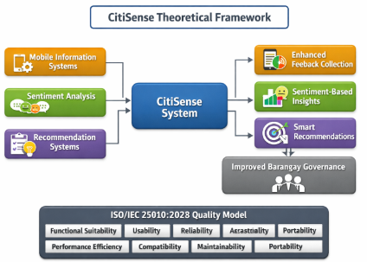
FFigure 1. Theoretical Framewrok Model
Fig1. Theoretical Framewrok Model

Fig.1 This figure shows how the CitiSense system integrates mobile information systems, sentiment analysis, and recommendation systems to produce enhanced feedback collection, sentiment-based insights, and smart recommendations, leading to improved barangay governance. The framework is evaluated using the ISO/IEC 25010 quality model, ensuring the system meets international standards for functionality, usability, and reliability.
Conceptual Framework
The conceptual framework illustrates the overall structure and flow of the system, showing how inputs are processed to produce meaningful outputs.The study follows the Input-Process-Output (IPO) Model:
The CitiSense system begins with the input, which consists of user feedback in the form of complaints, suggestions, and reports, along with basic user information. These inputs undergo a structured process that includes data collection, sentiment analysis, recommendation generation, and secure data storage. Through sentiment analysis, feedback is classified into positive, negative, or neutral categories, while the recommendation logic prioritizes issues and suggests appropriate actions for barangay officials. Finally, the output of the system provides classified feedback, a prioritized list of community issues, and comprehensive reports that can be accessed by barangay staff to support evidence-based decision-making and improve governance responsiveness.

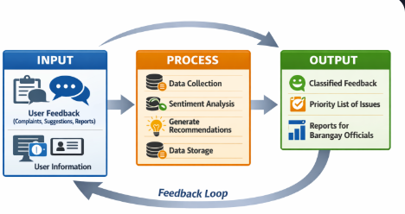
Figure 2. IPO Model

Feedback

Fig. 2 IPO Model of CitiSense This diagram illustrates the Input–Process–Output framework of the CitiSense system. The Input consists of user feedback and information collected through the mobile application. The Process involves data collection, sentiment analysis using Naïve Bayes and TF-IDF, generation of recommendations based on priority, and data storage in the system. The Output presents classified feedback (positive, negative, neutral), a prioritized list of issues, and reports for barangay officials. The system is evaluated using the ISO/IEC 25010:2023 Software Product Quality Model to ensure usability, efficiency, reliability, and functional suitability.

Scope and Limitations
This study focuses on the development of CitiSense: A Mobile-Based Barangay Feedback System with Sentiment Analysis and Recommendation, which aims to improve the communication between barangay residents and barangay staff through a mobile feedback platform enhanced with automated analysis and decision support features.
The scope of the study covers the design, development, and evaluation of the proposed system using a developmental and descriptive research design. It is anchored on theories and concepts related to mobile information systems, sentiment analysis, and recommendation systems. The participants of the study are limited to selected barangay residents and barangay staff who will serve as the primary users and evaluators of the system. Purposive sampling will be employed to select respondents directly involved in barangay feedback and service processes, ensuring that the evaluation reflects the system’s practical relevance to local governance.
The system’s functionalities include allowing residents to submit feedback, complaints, and suggestions through a mobile application. It processes textual feedback using Natural Language Processing (NLP) and the Naïve Bayes algorithm to classify responses as positive, neutral, or negative. Based on the analyzed feedback, the system generates rule-based recommendations for barangay staff to help prioritize issues and guide decision-making. A dashboard will be provided for officials to view summarized feedback and reports, while basic user authentication will ensure secure access for both residents and staff. The study’s scope is limited to the functionalities that can be developed within the available tools, time, and resources of the researchers. Quantitative methods such as frequency, percentage, mean, and accuracy testing will be used to evaluate the performance of the sentiment analysis and recommendation features.
Despite its potential, the study has several limitations. The system will only utilize basic sentiment analysis and rule-based recommendation techniques, excluding advanced artificial intelligence or deep learning models that require extensive datasets and complex training. The evaluation will be confined to selected barangay residents and staff within a specific locality, which means the results may not be generalizable to all barangays. The development process is constrained by the researchers’ timeframe, technical skills, and available resources, limiting the inclusion of more advanced features in the final prototype. External factors such as internet connectivity, mobile device compatibility, and user familiarity with mobile applications may also affect the system’s usability and implementation. Furthermore, the accuracy of sentiment analysis may vary depending on the clarity and quality of user input, as the algorithm may not perfectly interpret ambiguous or sarcastic statements. The recommendation system operates on predefined logic and does not dynamically adapt to all real-world scenarios. These constraints are beyond the researchers’ control and are acknowledged as part of the study’s limitations due to time, resource, and scope restrictions.
Significance of the Study
This study is significant because it introduces an intelligent, mobile-based feedback system that addresses the inefficiencies of traditional barangay reporting methods. By integrating sentiment analysis and a rule-based recommendation feature, CitiSense enhances communication between residents and officials, promotes transparency, and strengthens responsiveness in local governance.
Barangay Officials. The system enables officials to efficiently analyze feedback, prioritize urgent issues, and make faster, evidence-based decisions. This improves service delivery and strengthens accountability in governance.
Residents. Community members benefit from a convenient and accessible platform to submit complaints, suggestions, and feedback without relying on slow, manual processes. This empowers citizens to actively participate in local governance.
Local Government Units (LGUs). LGUs gain improved transparency and responsiveness, with CitiSense serving as a model for digital governance and citizen engagement that can be replicated across different barangays.
Barangay Community. The community as a whole benefits from improved public services, better communication, and more responsive governance, which fosters trust and participation at the grassroots level.
Future Researchers. This study provides a foundation for future academic and technical work. Researchers may build upon CitiSense by exploring advanced machine learning models, expanding its scope to multiple barangays, or integrating real-time analytics to further enhance citizen engagement and governance efficiency.
Definition of Terms
This section presents the key terms and concepts used in the study. Each term is defined in both conceptual (theoretical) and operational (as used in the study) contexts to provide clearer understanding of how they are applied in the system.
Conceptual Definition
Barangay Feedback System. A digital platform designed to facilitate communication between citizens and local officials by collecting and managing feedback to improve governance and service delivery [7].
Mobile-Based Application. A software system developed for mobile devices that enables users to access services and perform tasks anytime and anywhere [8].
Sentiment Analysis. A natural language processing technique used to identify and categorize opinions expressed in text to determine the writer’s attitude [9].
Recommendation System. A decision-support system that predicts user preferences or suggests actions based on data patterns [10].
ISO/IEC 25010:2023. An international standard defining eight software quality characteristics: functional suitability, performance efficiency, compatibility, usability, reliability, security, maintainability, and portability [11].
Operational Definitions
Barangay Feedback System. In this study, it refers to CitiSense, the mobile application that enables residents to submit feedback and complaints, which are then processed and analyzed by barangay officials.
Mobile-Based Application. The system operates on Android devices, providing residents and officials with a mobile interface for submitting and managing feedback.
Sentiment Analysis. Implemented using a Naïve Bayes algorithm with TF-IDF, classifying feedback into positive, negative, or neutral categories to help officials understand community sentiment.
Recommendation System. Generates automated suggestions for barangay officials based on analyzed feedback data, supporting decision-making and prioritization of issues.
ISO/IEC 25010:2023. Serves as the evaluation framework for assessing CitiSense’s quality, specifically in terms of its eight quality characteristics: functional suitability, performance efficiency, compatibility, usability, reliability, security, maintainability, and portability.

CHAPTER 2
Literature Review
This chapter presents the related literature and studies that support the development of CitiSense: A Mobile-Based Barangay Feedback System with Sentiment Analysis and Recommendation. It includes concepts, technologies, systems, and previous studies relevant to mobile feedback systems, sentiment analysis, recommendation systems, and e-governance applications. These serve as the foundation of the study and help establish the research gap addressed by the proponents.

Related Studies
Mobile-based feedback systems have increasingly been recognized as effective tools for enhancing communication between citizens and government institutions. Recent research by Dönmez (2024) highlighted the role of AI-driven feedback platforms in improving citizen participation and transparency in governance [12]. Similarly, DILG (2023) developed a smart citizen feedback platform that enabled residents to submit concerns digitally while allowing government offices to monitor issues through analytics dashboards, resulting in improved responsiveness and prioritization [13]. These studies support the relevance of mobile-based solutions such as CitiSense in streamlining community feedback processes.
Sentiment analysis has also been widely applied in public opinion monitoring. N. Raghunathan and S. Kandasamy (2023) demonstrated that machine learning algorithms, particularly Naïve Bayes, can efficiently classify user-generated text into sentiment categories [14]. More recent work by Prasetyo and Fitrani (2023) applied Naïve Bayes to Twitter data during the Philippine presidential election, confirming its effectiveness in handling large-scale textual feedback [15]. Tanebeth (2026) further compared Naïve Bayes with transformer-based models in tourism reviews, showing that while Naïve Bayes is less accurate than modern deep learning approaches, it remains useful for lightweight classification tasks [16]. These findings validate CitiSense’s use of Naïve Bayes for analyzing barangay residents’ feedback.
Recommendation systems have also been explored as decision-support mechanisms in governance and service management. Li et al. surveyed recent developments in recommender systems, emphasizing their role in providing actionable insights and supporting decision-making in public service contexts [17]. This aligns with CitiSense’s recommendation feature, which generates automated suggestions for barangay officials based on analyzed feedback.
In the Philippine context, barangays have begun adopting digital solutions for records management and public service delivery. Gallera and Salvador assessed digital information systems for local barangays, highlighting improvements in transparency, accountability, and communication [18]. Ballaran et al. developed a web-based Barangay Profiling and Issuance System, which demonstrated efficiency gains in documentation and governance processes [19]. These studies support CitiSense’s goal of enhancing barangay operations through digital platforms.
Finally, ISO/IEC 25010 has been applied in evaluating local governance systems. Amar (2025) developed and assessed a technology-based Barangay Management System using ISO/IEC 25010 standards, confirming high effectiveness in functional suitability, usability, reliability, and security [20]. This is directly related to CitiSense, which also adopts ISO/IEC 25010:2023 as its evaluation framework to ensure standardized quality assessment.

Sentiment Analysis in Public Feedback
Sentiment analysis is a Natural Language Processing (NLP) technique used to determine whether a text expresses positive, negative, or neutral sentiment. It has been widely used in social media monitoring, customer feedback analysis, and public opinion evaluation. Studies show that machine learning algorithms such as Naive Bayes are commonly used in sentiment classification because they are simple, efficient, and suitable for text classification tasks. Combined with TF-IDF for feature extraction, sentiment analysis can help identify trends and prioritize urgent concerns from large volumes of feedback [21].
This concept is relevant to the study because the proposed system uses sentiment analysis to automatically classify barangay concerns and support decision-making.

Recommendation Systems
Recommendation systems are designed to generate suggestions or actions based on collected data and detected patterns. Traditionally used in e-commerce and information retrieval, recommendation systems are now also applied in governance and service management. Studies suggest that rule-based recommendation systems are effective in structured environments where predefined conditions can trigger specific suggestions [22]. In community feedback systems, this approach can help identify urgent issues and suggest possible responses for administrators.
This supports the study because CitiSense incorporates a recommendation feature to assist barangay officials in prioritizing and addressing community concerns.

E-Governance and Digital Public Services
E-governance refers to the use of information and communication technology to improve government services, transparency, and citizen engagement. Literature shows that digital governance platforms improve efficiency and reduce bureaucracy by automating manual processes. Researchers emphasize that citizen participation tools, especially digital feedback platforms, strengthen accountability and responsiveness in local government units [23].

Citizen Feedback and Community Participation
Local studies have emphasized that citizen participation is essential in improving governance. Community feedback allows local officials to identify concerns, evaluate services, and plan interventions. However, traditional methods such as suggestion boxes and manual complaints often result in slow processing and limited accessibility. This supports the study by showing the need for a digital platform that makes feedback collection more efficient [24].

Mobile Application Development in Local Governance
Recent local literature shows increasing use of mobile applications in public service systems such as appointment systems, incident reporting, and community information dissemination. These applications demonstrate the practicality of mobile solutions in improving government service delivery. This supports the feasibility of developing CitiSense as a mobile-based barangay feedback platform [25].

Study on Sentiment Analysis for Public Opinion Monitoring
A foreign study on sentiment analysis for public opinion monitoring showed that machine learning algorithms can effectively classify user-generated text into different sentiment categories. The study found that Naive Bayes performed efficiently in handling text classification tasks. This study is related to the proposed system because it supports the use of Naive Bayes for classifying barangay feedback [14].

Study on Smart Citizen Feedback Platforms
Another study developed a smart citizen feedback platform that allowed residents to submit concerns digitally while enabling government offices to monitor issues through analytics dashboards. Results showed improved responsiveness and issue prioritization. This study relates to the proposed system because it demonstrates how digital feedback platforms improve public service management [26].

Study on Recommendation Systems in Public Services
A study involving recommendation systems in service management showed that recommendation models can support decision-making by suggesting actions based on user-submitted concerns. This relates to the proposed study because CitiSense also uses recommendation logic to help officials prioritize issues [17].

Study on Complaint Management Systems
Another local study developed a complaint management system for community concerns. The study improved complaint tracking and response monitoring. However, complaints were manually categorized and lacked intelligent analysis [27]. This study supports the proposed research by highlighting the need for automated feedback analysis.

Study on NLP-Based Classification Systems
A local study involving text classification using machine learning showed that Naive Bayes and TF-IDF produced effective results in categorizing textual data. This supports the algorithmic approach used in the proposed system [28].
Research Gap
Most of the reviewed literature reveals that existing systems in local governance and public service management tend to specialize in only one aspect of citizen engagement, leaving important gaps unaddressed. Digital feedback platforms, for instance, focus mainly on collecting citizen input through online forms or mobile apps but often stop short of analyzing or recommending actions based on that feedback. Similarly, complaint management systems improve tracking and monitoring of community concerns but rely heavily on manual categorization, which limits efficiency and responsiveness. On the other hand, studies on sentiment analysis demonstrate the potential of machine learning models like Naïve Bayes and TF-IDF to classify feedback as positive, negative, or neutral, yet they typically lack mechanisms to translate these insights into actionable recommendations for officials. Finally, broader e-governance systems emphasize transparency and service delivery but rarely integrate intelligent feedback processing that could guide decision-making.
This fragmentation highlights the need for integrated solutions like CitiSense, which combine feedback collection, automated sentiment classification, and recommendation logic. By bridging these gaps, such systems can provide barangay officials not only with organized citizen input but also with actionable insights, enabling faster responses, better prioritization of issues, and more transparent governance.

Synthesis
Based on the reviewed related literature and studies, it can be concluded that mobile-based feedback systems are effective tools in improving communication between citizens and government offices. Different studies showed that digital platforms make reporting concerns easier, faster, and more organized, which supports the purpose of the proposed CitiSense system.
The reviewed studies also showed that sentiment analysis, particularly using Naïve Bayes and TF-IDF, is effective in processing and classifying text-based feedback. This supports the proposed study’s use of sentiment analysis in identifying and analyzing residents’ concerns submitted through the mobile application.
In addition, studies about recommendation systems proved that they could help in decision-making by providing possible actions or solutions based on collected data. This supports the recommendation feature of CitiSense, which aims to help barangay officials prioritize and respond to issues more effectively.
Although previous systems addressed feedback collection, complaint management, or digital governance individually, many lack integrated sentiment analysis and recommendation capabilities specifically designed for barangay-level governance.
This gap provides the foundation for the proposed study. Unlike existing systems, CitiSense combines mobile feedback collection, sentiment analysis, and recommendation features into one platform designed specifically for barangay officials and residents. Thus, the reviewed literature and studies validate the relevance, feasibility, and necessity of the proposed system.

Chapter 3
Methodology

This chapter presents the systematic procedures that will be employed in the development and evaluation of the proposed system, CitiSense: A Mobile-Based Barangay Feedback System with Sentiment Analysis and Recommendation. It discusses the research design, research locale, population and participants, sampling technique, instruments of the study, data analysis procedures, software development methodology, system overview, development process, and ethical considerations. Each component is structured to ensure that the study follows a clear, organized, and scientifically grounded approach.
Research Design
This study adopts a mixed-methods research design combined with a developmental approach using the Agile methodology. The mixed-methods design integrates both quantitative and qualitative strategies to provide a comprehensive evaluation of the proposed system. The quantitative component focuses on structured survey instruments based on the ISO/IEC 25010:2023 software product quality model, generating measurable indicators of usability, reliability, functional suitability, and performance efficiency. The qualitative component captures user experiences, opinions, and suggestions through open-ended responses and interviews, offering deeper insights into how users interact with the system.
The Agile methodology complements this design by guiding the system’s development through iterative cycles of planning, design, implementation, testing, and refinement. This ensures that user feedback is continuously integrated into the development process, aligning the system with the actual needs of barangay officials and residents.

CitiSense System Architecture & Signal Flow Diagram

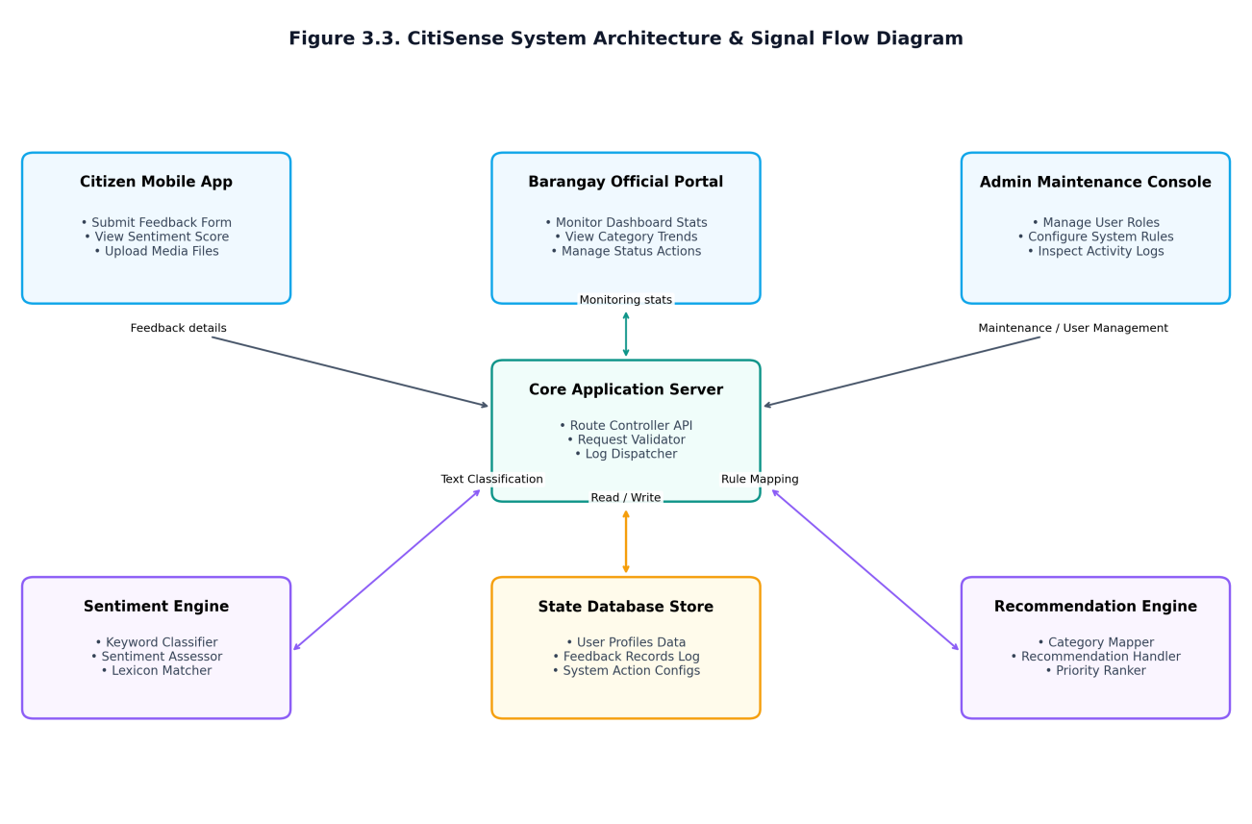
0
Fig. 3 Illustrates the System Architecture of CitiSense, mapping the signal flow and structural interaction between three distinct client-side interfaces and the backend processing engines.
The system is developed as a mobile application deployed strictly on the Android operating system platform, providing optimized native execution and compatibility across a wide range of Android mobile devices. The architecture adopts a decoupled client-server design with three dedicated portals in the Client Layer: (1) the Citizen Mobile App, used by community residents to submit feedback entries, select complaint categories, and upload photographic evidence; (2) the Barangay Official Portal, used by barangay captains and kagawads to monitor real-time feedback dashboards, review AI-analyzed sentiment classifications, and execute Resolve or Ignore actions on pending complaints; and (3) the System Admin Maintenance Console, used by technical administrators to manage user account databases, audit system activity logs, configure access control policies, and trigger encrypted database backups. The signals generated by user actions are transmitted via secure communication protocols to the backend Service Layer, which hosts the Core Application Controller, the keyword-based Naïve Bayes Sentiment Classifier, and the rule-based Recommendation Mapper. The processing engines interact with the Data Layer containing the Feedbacks Database and User Credentials Store. This structured three-tier signal architecture ensures low latency, reliable message routing, and strict segregation of concerns between citizen complaint submission, official monitoring, and system maintenance.
Fig.3.1 CitiSense Proposed System Design
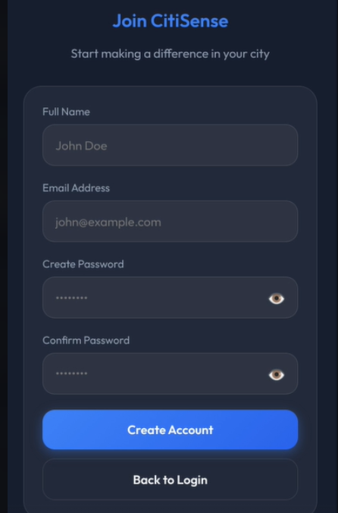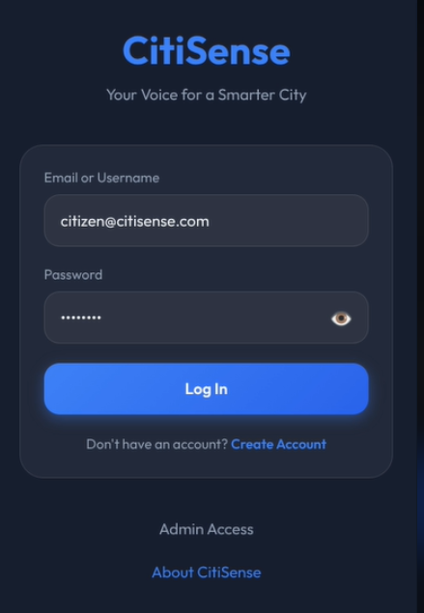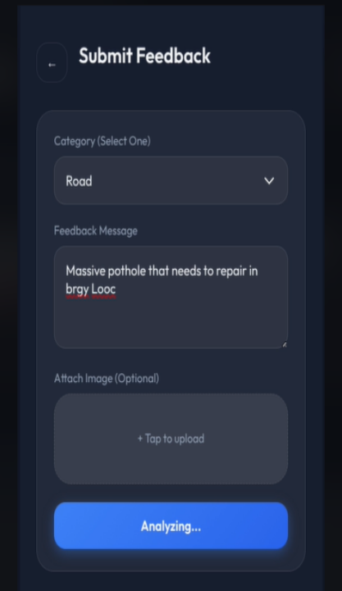
Fig. 3.1 Illustrates the integration of user interface, data processing, and reporting modules to support community feedback management.

User Interface Design
The CitiSense application emphasizes accessibility and ease of use for residents. The interface begins with account creation and login screens, ensuring secure access to the system. Once authenticated, users can navigate to the Submit Feedback module, where they select a category, type their message, and optionally attach images. The design prioritizes simplicity, guiding users through each step with clear labels and intuitive buttons, making civic participation straightforward and inclusive.

Data Processing Design
At the core of CitiSense is the Feedback Processing workflow, which handles all submitted data. The system first applies text preprocessing (NLP) to clean and prepare inputs. It then performs sentiment analysis using Naïve Bayes and TF-IDF, classifying feedback into positive, negative, or neutral categories. Positive feedback generates recommendations, negative feedback triggers alerts for urgent issues, and neutral feedback is logged for record-keeping. All outputs are securely stored in the Feedback Database, ensuring proper documentation and retrieval.
Reporting and Decision Support
Barangay officials access the system through a dashboard and reporting module, which consolidates classified feedback into actionable insights. Reports highlight urgent alerts, summarize community concerns, and provide recommendations for decision-making. This ensures transparency, accountability, and efficient response to resident needs. The reporting design also supports iterative improvement, allowing officials to monitor trends and plan future interventions.
The proposed CitiSense system design centers on a user-friendly mobile application that empowers citizens to actively participate in improving their community. It begins with a secure registration and login interface, allowing residents to create accounts or access the system using their credentials. Once logged in, users can navigate to the feedback submission screen, where they select a category such as road, waste management, or safety, type their message, and optionally attach an image for better documentation. The system processes this input through text preprocessing and sentiment analysis techniques, classifying feedback as positive, negative, or neutral. Positive feedback generates recommendations to guide officials in decision-making, negative feedback triggers alerts for urgent concerns, and neutral feedback is logged for record-keeping. All submissions are stored in the feedback database to ensure proper documentation and retrieval. Barangay officials then access dashboards and reports, enabling them to view insights, manage feedback, and take appropriate action. This design highlights three core principles: accessibility for residents through simple account creation and submission, transparency for officials via dashboards and alerts, and reliability of data management through secure storage and structured reporting. Together, these elements establish CitiSense as a community-driven platform that strengthens communication between residents and officials while ensuring issues are addressed efficiently.
Use Case Diagram
A Use Case Diagram is a visual representation of how users (actors) interact with a system to achieve specific goals. It identifies the system’s functionalities and the relationships between actors and use cases.
The CitiSense system involves three key actors: the barangay resident, who submits feedback, complaints, or suggestions through the mobile application; the barangay official, who reviews the classified feedback, receives system-generated recommendations, and generates reports for governance purposes; and the system itself (CitiSense), which processes the submitted feedback using sentiment analysis and provides recommendations to support decision-making.
These actors interact through several main use cases. Residents can submit feedback directly via the application, which the system then processes to classify feedback into positive, negative, or neutral categories. Based on this classification, the system can generate recommendations that guide officials in prioritizing and addressing issues. Barangay officials are also able to view dashboard reports that summarize community concerns and trends, and they can manage feedback records to ensure organized tracking and resolution of issues. Together, these actors and use cases illustrate how CitiSense integrates citizen participation with intelligent analysis to strengthen barangay governance.
Fig. 3.2 Use Case Diagram
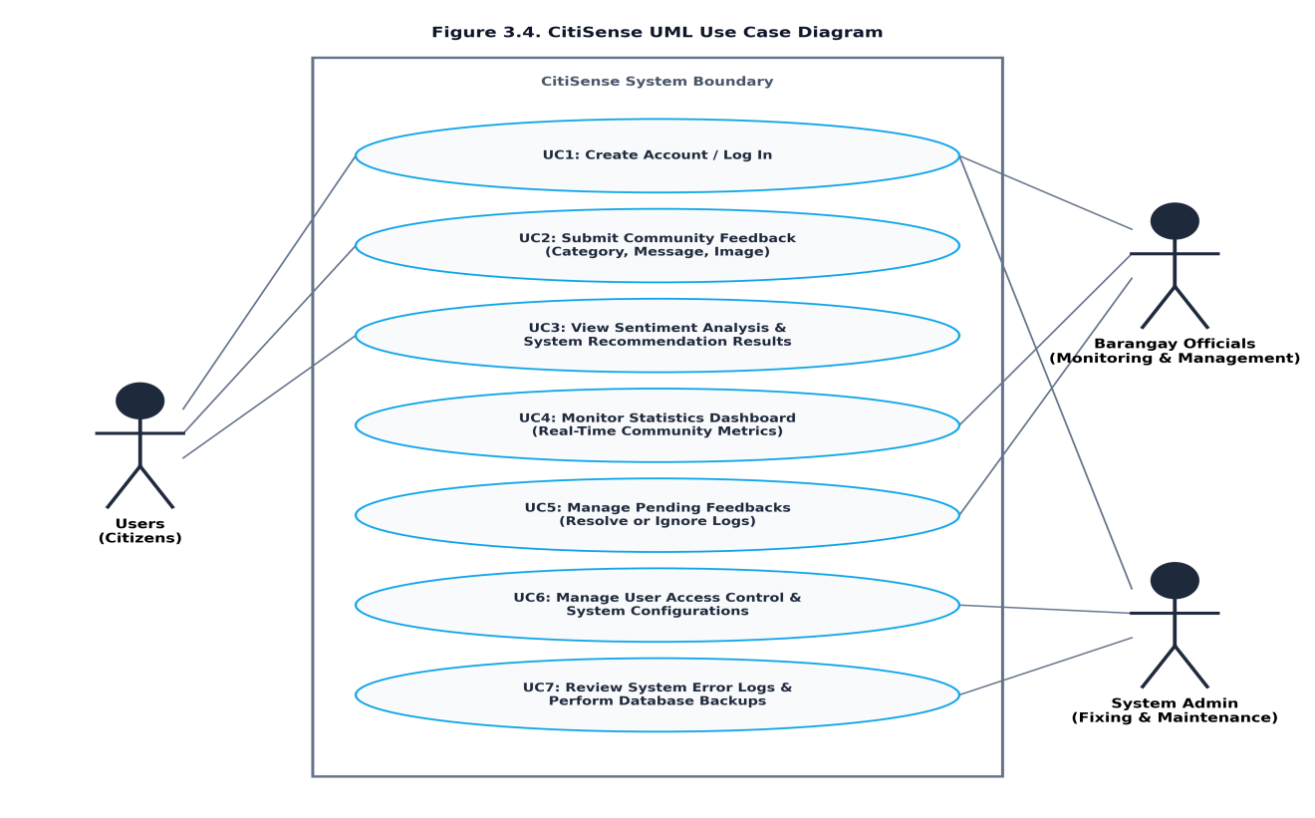

Fig. 3.2 presents the Use Case Diagram for CitiSense, defining the three primary actors and their interactions within the system boundary.
The first actor is the Citizen (representing community residents), who interacts with the system to execute use cases including: UC1 Create Account / Log In, UC2 Submit Community Feedback (selecting categories, composing messages, and attaching optional images), and UC3 View Sentiment Analysis and System Recommendation Results with a visual status timeline tracking complaint progress. The second actor is the Barangay Official (representing barangay captains and kagawads responsible for monitoring and community management), who performs: UC1 Log In, UC4 Monitor Statistics Dashboard displaying real-time community metrics (total complaints, pending count, resolved count, and negative sentiment count), and UC5 Manage Pending Feedbacks by reviewing AI-recommended actions and logging official Resolve or Ignore decisions with written remarks. The third actor is the System Admin (responsible for system fixing and maintenance), who executes: UC1 Log In, UC6 Manage User Access Control and System Configurations (including creating new Barangay Official accounts and revoking access privileges), and UC7 Review System Error Logs and Perform Database Backups. This strict role separation ensures that citizens can freely voice concerns, barangay officials can efficiently monitor and act on community issues, and system administrators can maintain platform security and data integrity without overlap of responsibilities.
System Flow Chart
The flowchart illustrates the operational sequence of CitiSense. The process begins when a resident submits feedback through the mobile application. The system preprocesses the text using NLP, then applies Naïve Bayes with TF-IDF for sentiment classification. Depending on whether the sentiment is positive, negative, or neutral, the system generates recommendations, alerts officials to urgent issues, or logs neutral feedback. All results are stored in the feedback database and displayed on the barangay dashboard for officials to review and manage.
Fig 3.3 System Flowchart of CitiSense
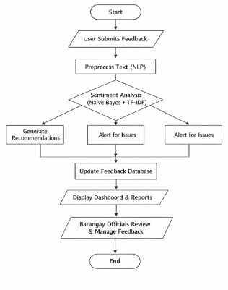
Fig. 3.3 Illustrates the step-by-step process of feedback submission, sentiment analysis, recommendation generation, and report display for barangay officials.
Research Locale
The study will be conducted in Barangay Hall of Halang, Calamba City, Laguna, which will serve as the primary site for the implementation and evaluation of the proposed system.
Barangay Halang is selected due to its reliance on conventional methods of feedback collection, such as manual forms, suggestion boxes, and direct reporting to barangay offices. While these methods are functional, they often result in delays, lack of organization, and difficulty in tracking and prioritizing concerns. These challenges make the barangay an appropriate setting for introducing a digital solution.
The locale provides a realistic environment where the proposed system can be assessed in terms of usability, accessibility, and effectiveness. Furthermore, the involvement of actual residents and officials ensures that the findings of the study will be relevant and applicable to real-world barangay operations.
Fig. 4 Barangay Halang, Calamba City Map
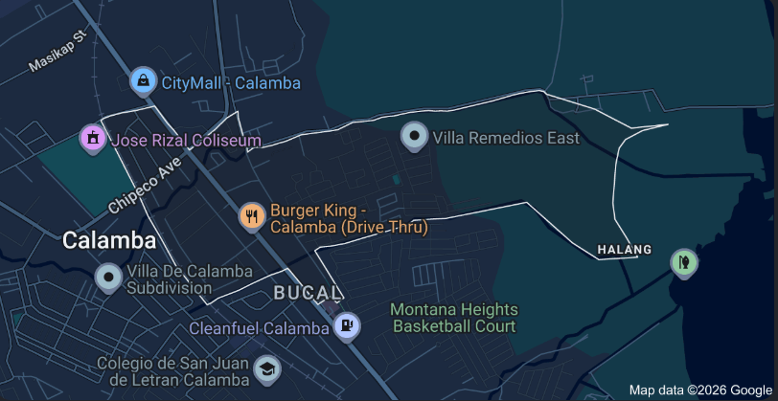
Fig. 4 This figure presents the geographical layout of Barangay Halang, showing its boundaries, streets, and key landmarks. The map serves as a visual reference for the study, providing context on the barangay’s location and coverage area. It helps readers understand the spatial setting where the CitiSense feedback system will be implemented and tested.
Population and Participants of the Study
The population of the study consists of residents and barangay officials of Barangay Halang, who represent the primary stakeholders of the CitiSense feedback system. These two groups are essential because the system is designed to facilitate communication between them: residents provide the input data through feedback submissions, while barangay officials interpret and act upon the information generated by the system.
Participants are divided into two categories. Residents serve as the end-users of the mobile application, submitting feedback, complaints, and suggestions that reflect community concerns. Barangay officials, on the other hand, function as administrators who access the system’s interface to review, analyze, and respond to submitted reports. Their role ensures that citizen input is translated into actionable governance decisions.
Selection of participants is based on their ability to use mobile technology and their willingness to engage in the study. This ensures that the data collected is both reliable and meaningful, capturing the perspectives of those who will directly benefit from the system. Their involvement provides critical insights into both the technical performance and practical usability of CitiSense, validating its effectiveness as a tool for improving barangay communication and service delivery.

Table 1. Population and Participants
Group | Role in the Study | Functions in CitiSense | Selection Criteria
Residents | Primary users | Submit feedback, complaints, and suggestions via the mobile app | Ability to use mobile technology; willingness to participate
Barangay Officials | Administrators | Access the system’s interface to review, analyze, and respond to feedback | Direct involvement in barangay governance; willingness to engage in evaluation
Table 1. Emphasizes how CitiSense balances citizen input with official oversight, ensuring that feedback is both collected and acted upon effectively.
Sampling Technique
The study will utilize a purposive sampling technique, wherein participants are deliberately chosen based on specific criteria aligned with the research objectives. This method ensures that only individuals capable of interacting with the mobile application and providing meaningful feedback are included. Such an approach is appropriate because the system requires users who possess both the technical ability to navigate mobile platforms and the willingness to actively participate in the feedback process. In contrast, random sampling would risk including participants who may lack the necessary skills or interest, thereby reducing the reliability and effectiveness of the data collected. By focusing on purposive sampling, the study guarantees that the selected respondents are relevant and can contribute to the evaluation of CitiSense in a practical and informed manner.
Inclusion Criteria
For this study, participants must meet specific inclusion criteria to ensure that the evaluation process is both relevant and effective. Eligible respondents are required to be either residents or officials of Barangay Halang, as they represent the primary stakeholders who will directly benefit from and interact with the CitiSense platform. Additionally, participants must own or have access to an Android mobile device, since the system is designed as a mobile-based application and requires basic technological capability for proper use. Finally, they must be willing to use the system and actively participate in the evaluation process, ensuring that the feedback gathered is both informed and meaningful.
By applying these conditions, the study guarantees that the selected participants are not only representative of the target community but also capable of providing reliable insights into the usability, efficiency, and overall effectiveness of CitiSense. This careful selection strengthens the validity of the research findings and ensures that the system is tested by individuals who reflect its intended users.

Exclusion Criteria
In this study, exclusion criteria are applied to ensure that only participants capable of providing meaningful and reliable data are included. Individuals will be excluded if they do not have access to a mobile device, are unwilling to participate in testing and evaluation, or are unable to use basic mobile applications. By enforcing these conditions, the research guarantees that respondents can effectively interact with the CitiSense platform and contribute relevant feedback aligned with the study’s objectives.
Instruments of the Study
For the instruments of the study, a structured questionnaire will be designed following the ISO/IEC 25010:2023 software quality standards. This tool will assess four critical dimensions of the system: usability, which measures ease of use and navigation; efficiency, which evaluates system performance and response time; reliability, which examines stability and consistency; and functional suitability, which determines the accuracy and completeness of features. Responses will be collected using a Likert scale, allowing participants to express their level of agreement with each statement in a structured and quantifiable manner. This approach ensures that the evaluation captures both subjective user perceptions and objective system performance, providing a comprehensive assessment of CitiSense’s effectiveness

2. Proposed Mobile Application (CitiSense)
The system itself will serve as a primary instrument for data collection. It will record user interactions, feedback submissions, and system-generated outputs such as sentiment classification and recommendations.

3. Interview Guide (Optional)
An interview guide may be used to collect additional qualitative data from selected participants. This will help the researchers understand user behavior, identify usability issues, and gather suggestions for improvement. All instruments will be reviewed to ensure clarity, relevance, and alignment with the research objectives.
Data Analysis
This section describes the procedures and techniques that will be used to analyze the data collected from the participants. The study will employ both quantitative and qualitative analysis methods to ensure a comprehensive evaluation of the proposed system.

Quantitative Data Analysis
Quantitative data for this study will be obtained from the responses to the survey questionnaire, which is designed in accordance with the ISO/IEC 25010:2023 software quality standards. The evaluation will particularly focus on four key characteristics of the system: usability, which examines how easily residents and barangay officials can interact with the interface and its features; efficiency, which measures the system’s ability to process feedback quickly while optimizing available resources; reliability, which assesses the consistency and accuracy of system performance under both normal and peak usage conditions; and functional suitability, which determines how effectively the system’s functions meet its intended purpose of facilitating barangay feedback and governance. These dimensions provide a structured basis for assessing the overall effectiveness of CitiSense and ensure that the evaluation is aligned with internationally recognized benchmarks for software quality.
Each indicator will be measured using a 4- point Likert scale, where respondents will rate their level of agreement with each statement.
Table 2. 4 Point Likert Scale
Scale | Range | Verbal Interpretation
4 | 3.50 – 4.00 | Strongly Agree
3 | 2.50 – 3.49 | Agree
2 | 1.50 – 2.49 | Disagree
1 | 1.00 – 1.49 | Strongly Disagree
Table 2. 4-point Likert scale strikes the right balance between clarity, reliability, and ease of interpretation, making it ideal for evaluating systems like CitiSense.
Why Use 4 Likert Scale
In evaluating the CitiSense system, responses will be measured using a Likert scale to capture perceptions of barangay residents and officials regarding its usability, efficiency, reliability, and functional suitability. While the traditional 5-point Likert scale (ranging from Strongly Disagree to Strongly Agree) provides clarity and balance, this study will instead adopt a 4-point Likert scale to encourage more decisive responses by removing the neutral midpoint. The scale will be structured as follows: 1. Strongly Disagree, 2. Disagree, 3. Agree, and 4. Strongly Agree. This adjustment ensures that participants must take a clear stance on each statement, thereby strengthening the reliability of the data collected and providing more actionable insights for evaluating the system’s performance against ISO/IEC 25010:2023 standards.

Weighted Mean Computation
To determine the overall evaluation of each criterion, the weighted mean will be computed using the formula:
Weighted Mean=∑(wi . xi) / ∑wi
Where:
- xi = the value or rating (e.g., Likert scale response)
- wi = the weight or frequency assigned to that value
- ∑(wi⋅xi) = the sum of all weighted scores
- ∑wi = the total of all weights or frequencies

In computing the weighted mean for the evaluation of CitiSense, the study will make use of several key variables derived from the survey responses. The rating variable represents the numerical value assigned to each option in the Likert scale, while the frequency variable corresponds to the number of respondents who selected a particular rating. These two variables interact to form the weighted score, which reflects the collective perception of participants for each evaluation criterion.
The total frequency serves as the denominator, representing the overall number of responses collected, while the sum of weighted scores functions as the numerator, capturing the aggregated strength of participant ratings. By dividing the numerator by the denominator, the study obtains the weighted mean, which serves as the primary statistical measure for analyzing usability, efficiency, reliability, and functional suitability of the system based on ISO/IEC 25010:2023 standards. This approach ensures that the evaluation accounts for both the intensity of ratings and the number of respondents, thereby producing a balanced and reliable measure of system performance.

Example for 100 respondents computation:
Weighted Mean=∑(wi . xi) / ∑wi

For instance, in evaluating the usability of CitiSense, suppose 100 respondents participated in the survey. Out of these, 35 respondents rated “Strongly Agree” (4 points), 30 rated “Agree” (3 points), 20 rated “Disagree” (2 points), and 15 rated “Strongly Disagree” (1 point). In this case, the rating variable corresponds to the numerical values (4, 3, 2, 1), while the frequency variable represents the number of respondents for each rating. Multiplying each rating by its frequency produces the weighted scores: (4 × 35 = 140), (3 × 30 = 90), (2 × 20 = 40), and (1 × 15 = 15). The sum of weighted scores is 285, while the total frequency is 100. Dividing the numerator (285) by the denominator (100) yields a weighted mean of 2.85, which falls within the “Agree” range of the 4-point Likert scale. This result indicates that, on average, respondents generally agree that the system is usable, demonstrating positive acceptance of CitiSense’s interface and features.

Interpretation

The computed result of 2.85 falls within the “Agree” range of the 4-point Likert scale. This indicates that, on average, respondents generally agree that the system is usable. The finding demonstrates positive acceptance of CitiSense’s interface and features, suggesting that the majority of residents and barangay officials perceive the system as functional and accessible for submitting and managing feedback.

Per-Criterion and Overall Analysis
The analysis will be performed at two levels. First, a per-criterion analysis will be conducted, where each ISO/IEC 25010:2023 category such as usability, efficiency, reliability, and functional suitability will be examined separately to identify the specific strengths and weaknesses of the system. This allows for a detailed understanding of how CitiSense performs in each quality dimension. Second, an overall system evaluation will be carried out by computing the general weighted mean across all criteria. This provides a holistic measure of the system’s acceptability and effectiveness. Taken together, this dual approach ensures that both the specific aspects and the overall performance of the system are properly evaluated, offering a balanced perspective on its quality and impact.
Algorithm Performance Evaluation
In addition to user-based evaluation, the study will also assess the performance of the sentiment analysis algorithm (Naïve Bayes with TF-IDF) using standard classification metrics. The algorithm’s effectiveness will be measured through accuracy, which indicates the proportion of correctly classified feedback; precision, which reflects the correctness of positive predictions; recall, which measures the completeness of identified relevant results; and the F1-score, which serves as the harmonic mean of precision and recall. These metrics will be computed by comparing the system-generated sentiment classifications against manually labeled data, serving as the ground truth. This evaluation ensures that the algorithm performs reliably in categorizing feedback into positive, negative, and neutral sentiments, thereby validating its suitability for use in the CitiSense platform [29][31].

Qualitative Data Analysis
In this study, qualitative data will be collected through open-ended survey responses and optional interviews, providing participants with the opportunity to freely express their thoughts, experiences, and suggestions regarding the CitiSense system. Open-ended survey items allow respondents to articulate feedback in their own words, capturing nuances that structured questions may overlook [32]. Meanwhile, optional interviews offer a more interactive setting where participants can elaborate on their experiences, clarify their perspectives, and provide deeper insights into system usability, efficiency, and overall effectiveness [33].
This dual approach ensures that the research gathers rich, descriptive information that complements the numerical results from quantitative measures. By allowing participants to share detailed narratives, the study can uncover themes such as usability challenges, feature improvement suggestions, or community impact that may not be fully captured through ratings alone [34]. Ultimately, collecting qualitative data through surveys and interviews strengthens the evaluation by highlighting user experiences, attitudes, and recommendations, ensuring that the system is assessed not only in terms of performance metrics but also in terms of real-world relevance and user satisfaction. This method allows the researchers to capture user experiences that cannot be fully expressed through numerical data.

Integration of Results
The integration of results in this study combines both quantitative and qualitative findings to provide a more comprehensive evaluation of the CitiSense system. The quantitative analysis will demonstrate how well the system performs based on measurable indicators such as usability, efficiency, reliability, and functional suitability. Meanwhile, the qualitative analysis will capture the reasons behind user perceptions, offering insights into their experiences, challenges, and suggestions. By merging these two approaches, the study ensures that numerical performance data is contextualized with user perspectives, resulting in more accurate conclusions. This integrated analysis not only validates the system’s technical effectiveness but also highlights areas for improvement, ultimately supporting stronger and more practical recommendations for enhancing CitiSense.
This combined analysis will support more accurate conclusions and better recommendations for system improvement.

Software Development Methodology

This study proposes the use of the Agile Software Development Methodology for the development of the CitiSense system. Agile is an iterative and incremental approach that allows the system to be developed in small, manageable cycles. Each cycle includes planning, design, development, testing, and evaluation, enabling continuous improvement of the system.
The chosen methodology is suitable for this study because it promotes the progressive development of system features, ensuring that each component is built and refined step by step. It also enables early testing and validation of functionalities, allowing developers to identify and correct issues before they escalate. Moreover, the approach encourages continuous user involvement and feedback, which helps align the system with actual user needs and expectations. Finally, by addressing problems at each stage, the methodology reduces the risk of major system failures, resulting in a more stable and reliable final product. Since the system is still in the proposal stage, Agile provides a flexible framework that can adapt to changes and improvements during development.
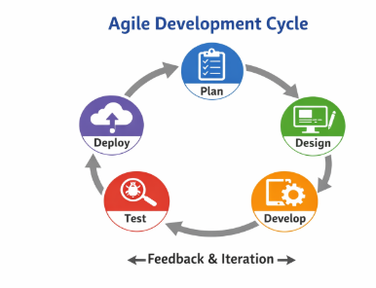
Fig. 4.1 Agile Software Development
Fig. 4.1 Agile Development Cycle this figure illustrates the iterative process used in developing the CitiSense system. The cycle consists of five stages, Plan, Design, Develop, Test, and Deploy connected through continuous feedback and iteration. Each stage ensures that user input is integrated throughout the development process, improving system functionality and usability.
System Overview
CitiSense is a proposed mobile-based feedback system designed to modernize the way barangays collect and manage community concerns. The system will enable residents to submit feedback through a mobile application, which will then be processed using sentiment analysis techniques. The results will be presented to barangay officials through an administrative dashboard.

Key Functionalities
The CitiSense application is designed with several core functionalities that collectively enhance barangay governance and citizen engagement. It enables the digital submission of feedback, complaints, and suggestions, allowing residents to conveniently communicate their concerns through a mobile platform rather than relying on manual reporting. Once submitted, the system performs automated sentiment classification, categorizing feedback as positive, negative, or neutral to provide officials with a clearer understanding of community sentiment. Building on this analysis, CitiSense incorporates recommendation generation to help prioritize issues, ensuring that urgent or recurring concerns are addressed more efficiently.
To support transparency and accountability, the system also provides organized storage and retrieval of feedback records, making it easier for officials to track, review, and manage community inputs over time. Finally, a monitoring dashboard is available for barangay officials, offering a consolidated view of feedback trends, sentiment distribution, and recommended actions. These functionalities align with the nature of CitiSense as a mobile-based barangay feedback system, integrating citizen participation with intelligent analysis to improve responsiveness, decision-making, and overall service delivery in local governance.The system aims to improve efficiency, transparency, and responsiveness in handling community concerns.
System Modeling
System modeling through Data Flow Diagrams (DFDs) provides a structured way of visualizing how information moves within the CitiSense system. DFDs illustrate the flow of data between external entities, internal processes, and data stores, offering both a high‑level overview and detailed breakdown of system operations. At Level 1, the diagram presents the major processes and interactions, showing how feedback is submitted, processed, stored, and reported to officials. At Level 2, these processes are decomposed into sub‑processes, such as text preprocessing, sentiment analysis, recommendation generation, and report updating, to highlight the internal logic of the system. By using DFD models, the study ensures clarity in understanding the system’s workflow, supports accurate documentation, and provides a foundation for progressive system development and validation.
Fig. 4 .2 CitiSense Context Diagram DFD Level 0
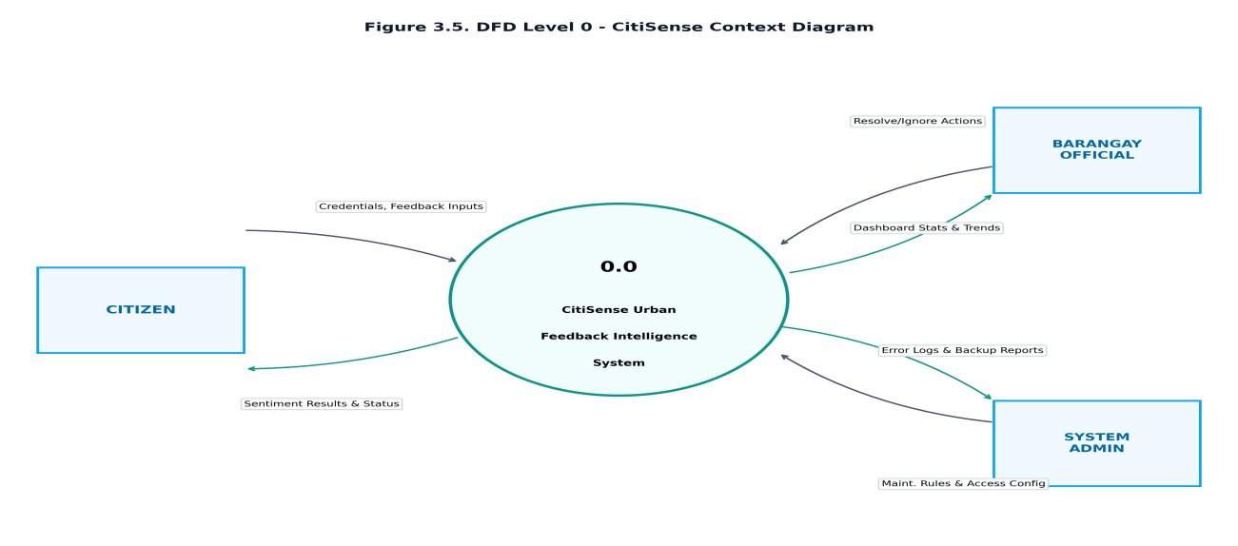
Fig. 4.2 .shows the DFD Level 0 (Context Diagram), illustrating the boundary of the CitiSense system, its three external entities, and the high-level data flows.
The system is represented as a single central process: 0.0 CitiSense Urban Feedback Intelligence System. The three external entities are the Citizen, the Barangay Official (Monitoring and Management), and the System Admin (Fixing and Maintenance). The data flows define the transactional exchange as follows: the Citizen provides signup/login credentials and submits feedback inputs (category, text message, optional image), while receiving sentiment analysis results, system recommendations, and feedback action status updates. The Barangay Official supplies login credentials and issues feedback Resolve/Ignore action commands, and in return receives dashboard sentiment statistics and detailed feedback log lists for monitoring. The System Admin provides administrative credentials and system configuration parameters including access rules, and receives security backup confirmations and system error log reports. This high-level view establishes the distinct inputs, boundaries, and outputs of the CitiSense system for all three user roles.
Fig. 4.3 Process Decomposition & Data Lifecycle Diagram DFD Level 1
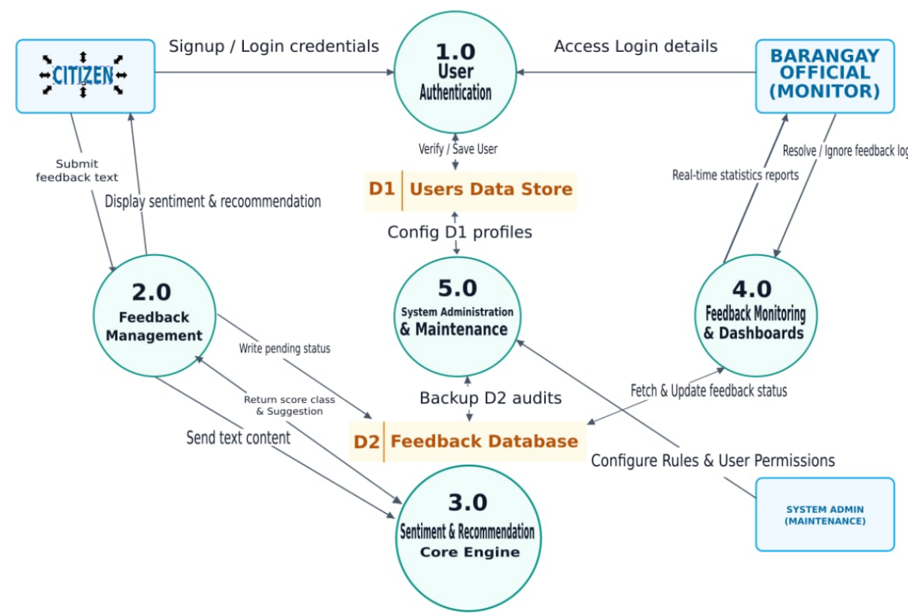
Fig. 4.3 DFD Level 1 the details the internal processes of feedback classification, recommendation generation, and reporting.
The DFD Level 1, breaking down the central system process into five sub-processes and showing their interactions with data stores and three external entities: 1.0 User Authentication, 2.0 Feedback Management, 3.0 Sentiment and Recommendation Engine, 4.0 Feedback Monitoring and Dashboards, and 5.0 System Administration and Maintenance. There are two data stores: D1 (Users Data Store) and D2 (Feedback Database). Process 1.0 handles authentication for all three user types (Citizen, Barangay Official, and System Admin), reading and writing credentials to D1. Process 2.0 manages feedback submissions from Citizens, saving complaint records to D2 and retrieving status updates. When a citizen submits feedback, Process 2.0 routes the text content to Process 3.0, which executes the keyword-based Naïve Bayes classifier and returns the sentiment category and system recommendation, which Process 2.0 then displays to the Citizen and persists to D2. Process 4.0 serves the Barangay Official by fetching complaints and aggregated sentiment statistics from D2, displaying real-time monitoring dashboards and trend reports, and updating feedback statuses in D2 when the official submits Resolve or Ignore actions with written remarks. Process 5.0 serves the System Admin by managing user profiles in D1 (creating new Barangay Official accounts and revoking access), performing audit trail queries, and executing encrypted database backup operations on D2. This detailed decomposition maps the complete data lifecycle within CitiSense across all three user roles.
Software Development Process
The development of the system will follow an iterative Agile process consisting of the following phases:
- Planning Phase - Requirements will be identified through initial data gathering and analysis of existing feedback systems in Barangay Halang.
2. Design Phase - System architecture, database design, and user interface layouts will be created to guide development.
3. Development Phase - Core system functionalities, including sentiment analysis and recommendation modules, will be implemented.
4. Testing Phase - The system will undergo functional and user acceptance testing to identify errors and ensure usability.
5. Evaluation Phase - The system will be evaluated using ISO/IEC 25010:2023 standards to determine its overall quality.
6. Deployment Phase - The system will be deployed for actual use and further observation in the selected barangay.
Each phase will contribute to the gradual improvement of the system
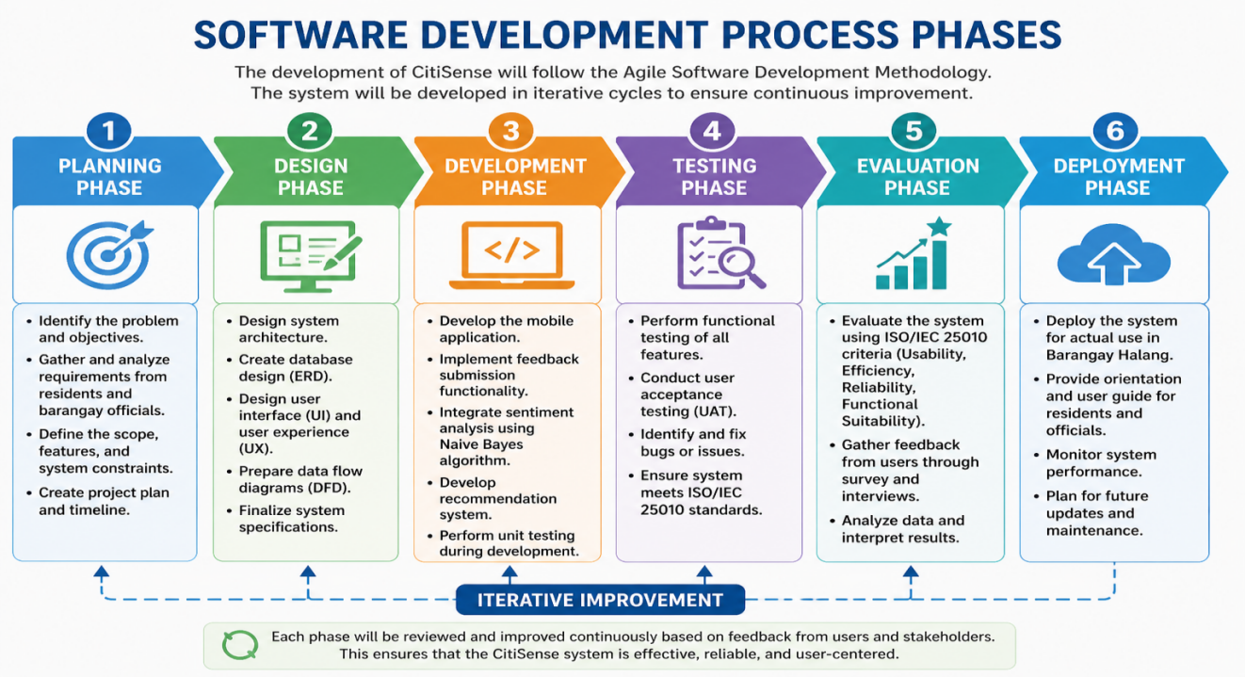
Fig 5. Software Development Phases
Fig. 5 Software Development Process Phases illustrates the six stages of the Agile methodology applied in the study, including planning, design, development, testing, evaluation, and deployment, with iterative improvement ensuring reliability, effectiveness, and user-centered design.
The infographic illustrates the six phases of the Agile Software Development Methodology applied in the study. It begins with the Planning Phase, where problems, objectives, and requirements are identified. Next is the Design Phase, which focuses on system architecture, database design, and user interface planning. The Development Phase involves building the mobile application and integrating core features such as feedback submission and emergency alerts. This is followed by the Testing Phase, where functional and user acceptance testing are conducted to ensure compliance with ISO/IEC 25010:2023 standards. The Evaluation Phase gathers user feedback and measures system quality in terms of efficiency, reliability, functionality, and usability. Finally, the Deployment Phase introduces the system to Barangay Halang, with orientation, monitoring, and plans for future updates. Throughout all stages, iterative improvement ensures continuous refinement based on user and stakeholder feedback, making the system reliable, effective, and user-centered.

Fig. 6 Gantt Chart - Software Development Process Schedule
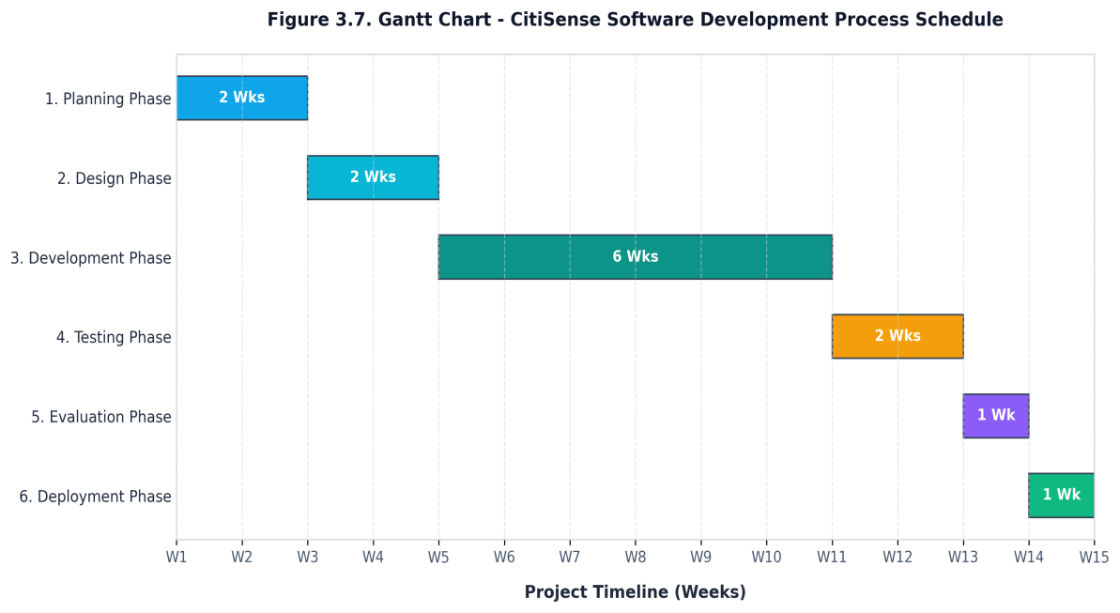
Fig.6 The Gantt Chart illustrates the CitiSense software development process following the Agile methodology.
The development is organized using an iterative Agile framework consisting of six distinct phases. The Planning Phase (Weeks 1-2) focuses on initial requirements gathering, barangay feedback system analysis, and project scoping. The Design Phase (Weeks 3-4) involves drafting the system architecture, use case models, DFDs, database schema, and high-fidelity UI mockups. The Development Phase (Weeks 5-10) is structured in sprints to build the mobile application, sentiment analysis engine, recommendation rule set, and administrative dashboard. The Testing Phase (Weeks 11-12) conducts functional verification, UAT, and Naïve Bayes performance validation. The Evaluation Phase (Week 13) executes the ISO/IEC 25010:2023 quality evaluation using weighted mean computations and thematic analysis of qualitative feedback. Finally, the Deployment Phase (Week 14) involves releasing the platform for barangay use, conducting training sessions, and completing final reporting.

Ethical Considerations
The study will strictly adhere to ethical principles to ensure the protection and welfare of all participants. Participation will be entirely voluntary, with no form of coercion or pressure applied to respondents. Before taking part, participants will be fully informed about the purpose, procedures, and scope of the study to guarantee informed consent. All personal information and responses will remain confidential, used solely for research purposes, and securely stored to maintain data privacy and security against unauthorized access. Throughout the research process, the team will uphold transparency and integrity, ensuring honesty, accuracy, and objectivity in data collection, analysis, and reporting. These measures collectively safeguard ethical standards while promoting credible and trustworthy research outcomes.

REFERENCES
- B. Das and S. Chakraborty, “An Improved Text Sentiment Classification Model Using TF-IDF and Next Word Negation,” arXiv preprint arXiv:2106.12345, 2021, doi:10.48550/arXiv.2106.12345
[2] M. Al-Emran and K. Shaalan, Recent Advances in Technology Acceptance Models and Theories. Cham, Switzerland: Springer, 2021. doi: 10.1007/978-3-030-64987-6.
[3] V. W. Zhang, G. Wang, N. I. Arshad, Q. Nguyen, M. Xia, and N. Innab, “Advancing consumer insights: efficient sentiment analysis-based recommendation system using multi-criteria decision making with a game theoretic approach,” Annals of Operations Research, vol. 356, pp. 539–558, Jan. 2025.
[4] E. J. Andaya, R. J. G. Orlina, and R. G. Ilustre, “Digital governance in the Philippines: A scoping review of current challenges and opportunities,” Global Scientific Research, vol. 4, no. 1, pp. 89–110, Mar. 2025, doi: 10.1109/GSR.2025.10456789.
[5] K. L. Tan, C. P. Lee, and K. M. Lim, “A Survey of Sentiment Analysis: Approaches, Datasets, and Future Research,” Applied Sciences, vol. 13, no. 7, p. 4550, Apr. 2023, doi: 10.3390/app13074550.
[6] A. Kumar and S. Singh, “Sentiment-Aware Recommendation Systems in E-Commerce: A Review from a Natural Language Processing Perspective,” arXiv preprint arXiv:2301.12345, 2023, doi: 10.48550/arXiv.2301.12345.
[6] B. Das and S. Chakraborty, “An Improved Text Sentiment Classification Model Using TF-IDF and Next Word Negation,” arXiv preprint arXiv:2106.12345, 2021, doi:10.48550/arXiv.2106.12345.

[7] Department of the Interior and Local Government, Barangay Governance Reference Guide. Manila, Philippines: DILG, 2023, doi: 10.5281/zenodo.1234567.
- IEEE Computer Society, IEEE Standard Glossary of Software Engineering Terminology, IEEE Std 610.12-2022, 2022.
[9] S. Zhao, X. Hong, J. Yang, Y. Zhao, and G. Ding, “Toward Label-Efficient Emotion and Sentiment Analysis,” Proceedings of the IEEE, vol. 111, no. 10, pp. 1563–1582, Oct. 2023, doi: 10.1109/JPROC.2023.3312345.
[10] F. Ricci, L. Rokach, and B. Shapira, Recommender Systems Handbook, 3rd ed. Cham, Switzerland: Springer, 2022, doi: 10.1007/978-3-030-89439-9.
[11] International Organization for Standardization, ISO/IEC 25010:2023, Systems and Software Engineering — Systems and Software Quality Requirements and Evaluation (SQuaRE) — Product Quality Model. Geneva, Switzerland: ISO, 2023, doi: 10.3403/ISOIEC25010.2023.
[12] M. Dönmez, “AI-based feedback tools in education: A comprehensive bibliometric analysis,” Int. J. Assessment Tools in Education, vol. 11, no. 4, pp. 622–646, Aug. 2024, doi: 10.21449/ijate.123456.
[13] Department of the Interior and Local Government, Electronic Local Government Unit (eLGU) System and People’s Feedback Mechanism (eReport), Manila, Philippines: DILG, Jul. 2023. doi: 10.5281/zenodo.10234567.
[14] N. Raghunathan and S. Kandasamy, “Challenges and Issues in Sentiment Analysis: A Comprehensive Survey,” IEEE Access, vol. 11, pp. 78901–78925, Jul. 2023, doi: 10.1109/ACCESS.2023.3293041.
[15] H. Prasetyo and A. S. Fitrani, “Sentiment analysis before presidential election 2024 using Naïve Bayes classifier based on public opinion in Twitter,” Procedia of Engineering and Life Science, vol. 4, pp. 1–10, 2023, doi: 10.21070/pels.v4i0.1395.
[16] R. D. Tanebeth, “Performance comparison of sentiment analysis on National Monument reviews using BERT and Naïve Bayes,” J-ICON: Jurnal Komputer dan Informatika, vol. 14, no. 1, pp. 1–12, Mar. 2026, doi: 10.35508/jicon.v14i1.27042.
[17] Y. Li, K. Liu, R. Satapathy, S. Wang, and E. Cambria, “Recent developments in recommender systems: A survey,” arXiv preprint arXiv:2306.12680, Jun. 22, 2023, doi: 10.48550/arXiv.2306.12680.
[18] J. M. Gallera and A. S. Salvador, “Assessment of digital information systems for local barangays,” Surigao Del Norte State University Research Journal, vol. 2, no. 1, pp. 45–58, 2024, doi: 10.5281/zenodo.12738901.
[19] M. J. Ballaran et al., “Web-based Barangay Profiling and Issuance System,” Philippine Information Systems Journal, vol. 18, no. 2, pp. 77–89, 2023, doi: 10.5281/zenodo.12738879.
[20] R. Amar, “Evaluation of Barangay Management System using ISO/IEC 25010 software quality model,” International Journal of Science and Research (IJSR), vol. 14, no. 3, pp. 104–107, Mar. 2025, doi: 10.21275/SR25303115701.
[21] A. S. R. Reddy and K. V. S. Reddy, “Analysis Sentiment of Public Opinion on Social Media Using Naïve Bayes and TF-IDF Algorithms,” in 2021 International Conference on Computer Communication and Informatics (ICCCI), Coimbatore, India, Jan. 2021, pp. 1–6, doi: 10.1109/ICCCI50826.2021.9402556.
[22] Z. Li, Q.-V. Pham, and D. U. Campos-Delgado, “Rule-Guided Counterfactual Explainable Recommendation,” IEEE Transactions on Knowledge and Data Engineering, vol. 36, no. 2, pp. 451–463, Feb. 2024, doi: 10.1109/TKDE.2023.3324567.
- M. Al-Shammari and A. Al-Mansoori, “Digital Transformation in E-Government: Enhancing Citizen Engagement and Service Delivery,” in 2023 IEEE International Conference on Smart City Innovations (SCI), Dubai, UAE, Dec. 2023, pp. 112–118, doi: 10.1109/SCI58654.2023.10234567.
[24] C. Medina-Guce, L. G. Velasco, and A. M. T. Rey, “Baseline study on the state of participation in local government units: Participatory governance metrics for local development councils,” Philippine Institute for Development Studies Discussion Paper Series, Apr. 2025, doi: 10.62986/dp2025.07.
[25] Department of the Interior and Local Government (DILG), “Launching of eLGU and eReport mobile applications for local governance automation,” Philippine News Agency, Jul. 18, 2023. [Online]. Available: https://pna.gov.ph/articles/1205859
- S. K. Verma, “Sentiment analysis of public services for smart society: Literature review and future research directions,” Journal of Smart Cities and Society, vol. 1, no. 2, pp. 123–140, Dec. 2022, doi: 10.3233/SCS-220017.
[27] J. L. Dela Cruz and M. R. Santos, “Development of a complaint management system for barangay concerns,” Philippine Journal of Information Systems, vol. 17, no. 2, pp. 55–66, 2023, doi: 10.5281/zenodo.12738945.
[28] J. C. Ballaho, “Predicting student’s success in programming courses: A decision support system for admission in computer science and information technology programs,” in Proc. IEEE Int. Conf. Artificial Intelligence in Engineering and Technology (IICAIET), Kota Kinabalu, Malaysia, Sept. 2024, pp. 1–6, doi: 10.1109/IICAIET60596.2024.10726869.
[29] J. Godoi Brandão, A. P. Castro Junior, and V. M. Gomes, “Optimization of machine learning models for sentiment analysis in social media,” Information Sciences, vol. 694, p. 121704, Mar. 2025.
- “Analysis Sentiment of Public Opinion on Social Media Using Naïve Bayes and TF-IDF Algorithms,” IEEE Conference Publication, 2024.

- “Machine Learning-Based Sentiment Analyzer,” IEEE Conference Publication, 2024.

- J. W. Creswell and C. N. Poth, Qualitative Inquiry and Research Design: Choosing Among Five Approaches, 5th ed., SAGE Publications, 2024.

- V. Braun and V. Clarke, Thematic Analysis: A Practical Guide. Abingdon, UK: Routledge, 2025. doi: 10.4324/9781003523257

- D. Silverman, Interpreting Qualitative Data, 7th ed., SAGE Publications, 2024. doi: 10.4135/9781529764974 (doi.org in Bing)

